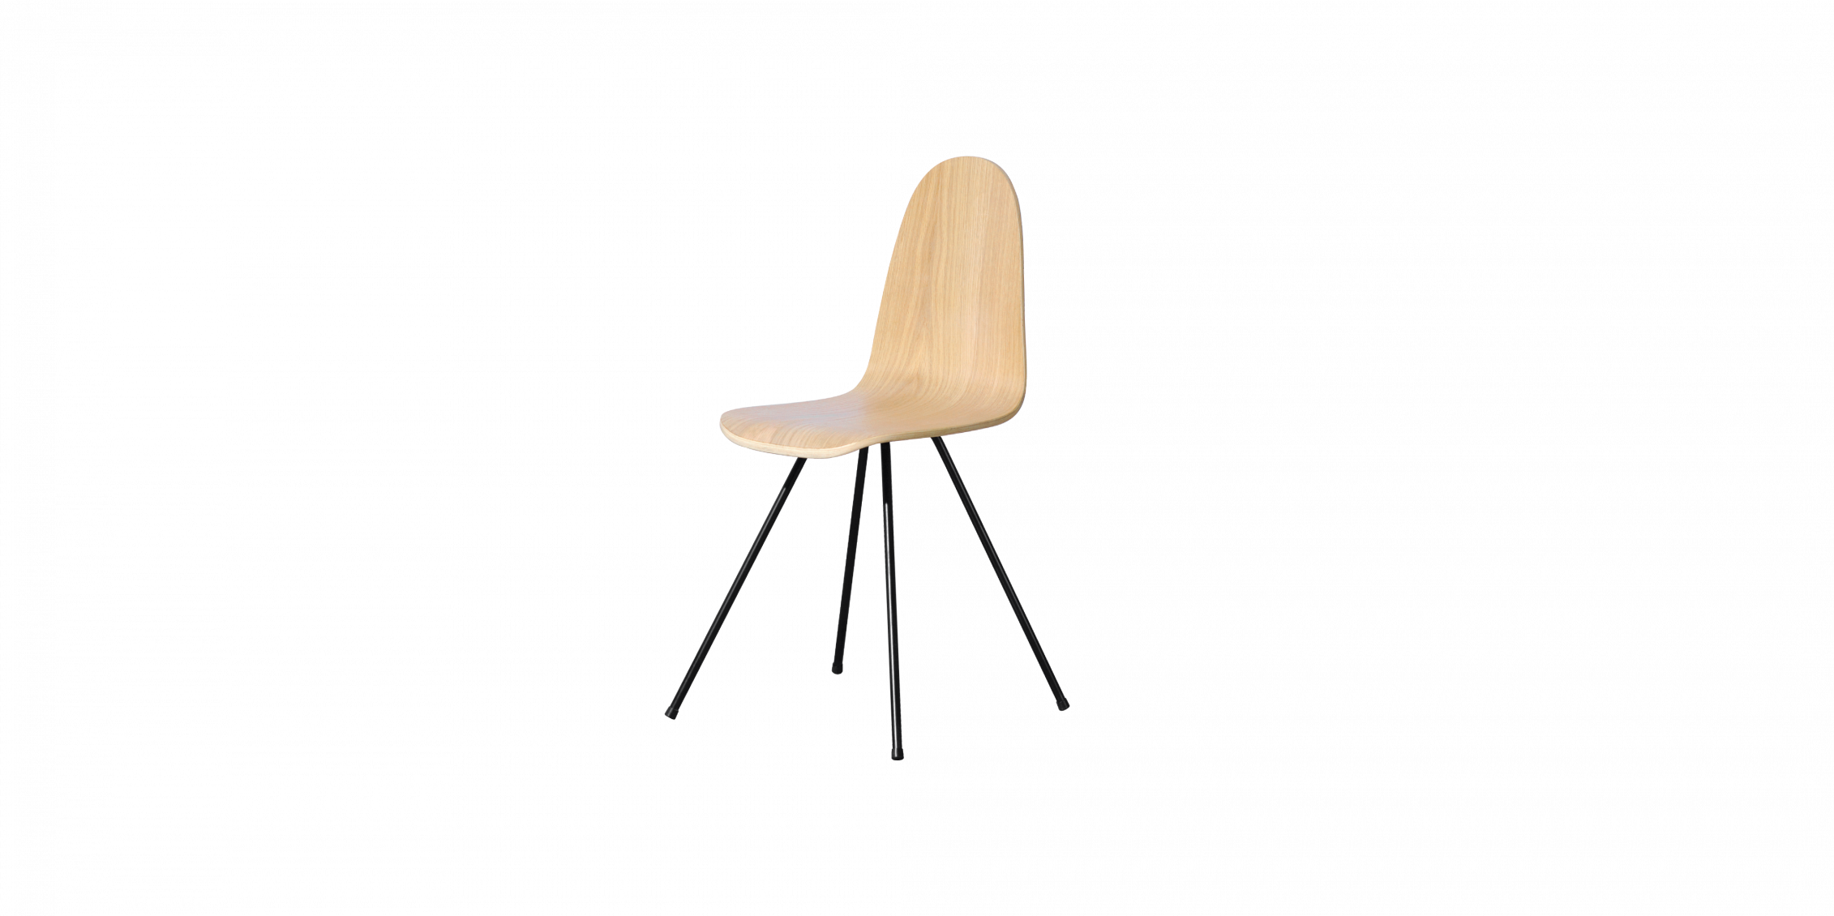

$72,97Compact yet sophisticated design combined with contemporary and diverse colors, the Z-C05 chair is a perfect choice for petite-sized houses or public spaces.

